IVY TECH COMMUNITY COLLEGE / LAFAYETTE
SDEV 220
Final Exam Lab

YOUR NAME: __________Giovanna Gorski__________________________________________

INTRODUCTION: In this lab, you will demonstrate the use of GUI interfaces, including radio buttons, label and entry widgets, IntVar objects, and message boxes.

ASSIGNMENT: Programming Exercise #7 on page 563, with these specifications.
- Programming Exercise #7 (Long-Distance Calls):
  - Name your Python class program long_distance.py.
  - Display the full Rate Category description and Rate per Minute with each radio button.
  - Hint: Use Program 14-12 for help with creating radio buttons, IntVar objects and message boxes. Program 14-10 helps you with label and entry widgets.
  - Here is an example of what your program interaction might look like, if the user clicks the Evening button and enters 10.5 into the length entry box. Yours does not have to look exactly like this, if it works correctly.
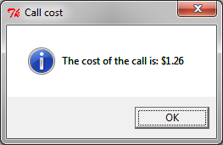
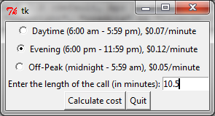

  - Be sure to include the four lines of documentation at the top of each program, and a short comment above every line or small section of Python code.
HOW TO SUBMIT YOUR ASSIGNMENT: Save and close your Python files. In Blackboard, go to the Class Session where this assignment is posted, attach your Python file (long_distance.py), and submit the file.

